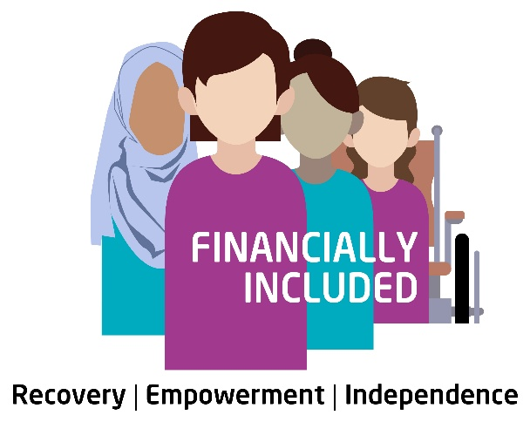

Job Description: Welfare Rights Officer
Financially Included is a specialist welfare rights project supporting women who have experienced economic abuse or other forms of gender-based violence that have impacted their ability to achieve financial independence and stability.
We are entering an exciting new phase of work and are looking to recruit a dedicated and experienced advice worker to join our team.
If you are passionate about social justice, thrive in a fast-paced, innovative, and collaborative environment, and have a strong understanding of the feminist analysis of gender-based violence, this could be the ideal opportunity for you.

Purpose
The postholder will provide to clients; an intensive, trauma-informed 1 to 1 support service in Income maximisation and Money advice.
Additionally, the postholder will provide a holistic service covering financial capability inputs and onward referrals and sign posting.
The postholder will have excellent knowledge of all state benefits, tax credits and grants available to maximise incomes, this includes assessment of entitlement, assistance to make relevant applications, an understanding of the reconsideration and appeal processes.
Alternatively, the postholder will have excellent knowledge of all Money advice practices to support clients determine strategies for managing debts. This will include, liabilities, debt options, negotiation strategies and direct support for clients to pursue any chosen debt strategy. The postholder will provide a holistic service by ensuring the client is aware of priority expenditure, have developed an improved knowledge of money management and alternative financial products available.
The post holder will fully utilise the Advicepro case management software provided to organise all client interventions and record them in line with the Scottish National Standards for Advice and Information.
The postholder will manage a large client caseload and display excellent communication skills

✓ To provide a one to one, trauma informed advice service.

✓ To generally counsel the debtor to establish client’s financial/debt situation.

✓ To maximise client’s income through benefit or tax system where appropriate.

✓ To liaise between creditor and debtor and to negotiate on debtor’s behalf.

✓ To provide budgetary advice, where appropriate.

✓ To provide a general welfare rights service including assistance with applications, reviews, appeals.

✓ To negotiate with statutory bodies on client’s behalf.

✓ To provide advice across a number of platforms; face to face at office, home visits or outreach locations, via telephone or helpline.

✓ To maintain accurate records of all casework in line with GEMAP procedures.

✓ To collaborate with the team to strengthen responses for victim survivors.

✓ To ensure all advice/information given is accurate.

✓ Any other reasonable duties designated by the advice manager

➢ To provide support to the targeted groups on all aspects of personal finance

➢ Report on progress to line manager and client

➢ Participate in all monitoring, evaluation and supervision as required

➢ Play an active role in forward planning and decision making within the service

➢ Work in a flexible way to suit any urgent or unforeseen requirements of the post

Person Specification

Specification | Essential | Desirable
Qualifications | Relevant training in General Advice, Welfare Rights or debt advice
Experience | At least two years providing 1 to 1 advice to clients, either paid or voluntary.  Excellent Knowledge of the benefit system across all client groups, understanding of Universal Credit and legacy benefits.  Demonstratable experience supporting clients to deal with priority and non-priority debts and providing support on money management issues.  Experience of working alongside external partners or as part of a multi-disciplinary service. | Understanding of GDPR legislation  Excellent customer care practice  Understanding of Equalities and discrimination legislation  Excellent administrative experience.
Knowledge and understanding | Relevant Legislation and regulation relating to all benefits, tax credits and debt. | Use of a case management system.

Please submit completed application forms to amberc@gemap.co.uk by 1pm Monday 1st Sept 2025.
Interviews are due to be held on Friday 12th Sept.

